Decree on pastoral activities during the COVID-19 pandemic and after 11 September 2020
August 20, 2020 | Health, Public Health Concerns

Whereas the Department of Health and Senior Services of the State of Missouri and the Center for Disease Control and Prevention of the United States federal government continue to recommend the observance of social distancing and the use of face masks when in gatherings; that persons 65 years of age and older, as well as those with certain medical conditions, avoid public gatherings as much as possible; and the practice of frequent handwashing or use of hand sanitizers; and
Whereas the common good demands that the public health requirements and recommendations of the state are to be observed whenever possible; and
Whereas having received the recommendation of the Presbyteral Council to extend the current norms with regard to the pandemic;
I therefore declare, as the diocesan bishop, the following:

All the faithful of the Diocese of Jefferson City, and those who are present in the territory of the diocese, are dispensed from the obligation to attend Mass on Sundays and holy days of obligation until 27 November 2020, provided that for days of precept they do one of the following:

Prayerfully participate in the Sunday or holy day of obligation Mass livestreamed from their parish church or chapel, the Cathedral, the Vatican, or of any Mass of the day celebrated in communion with the Roman Catholic Church.

Prayerfully read and meditate on the readings of the Mass for the Sunday or holy days of obligation, and recite the Rosary or Divine Mercy Chaplet.

Parishes are highly encouraged to livestream Masses for Sundays and holy days of obligation indefinitely.

Those who are symptomatic for COVID-19 are not permitted to enter church properties, in accordance with national, state and local health directives. All are asked to check their temperature at home before going to church.

Those who are 65 years of age or older, and those with medical conditions, are highly encouraged not to go to Mass, especially when it is likely that there will be a large number of the faithful in attendance or if social distancing and the wearing of face masks are not observed.
Those who do not attend Mass on Sundays are encouraged to attend Mass on a weekday if it would be easier to observe the proper social distancing and other health recommendations.

The celebration of weddings outside of Mass may take place outdoors on the grounds of and in proximity to the parish church or chapels, according to the judgement of the pastor, parochial administrator, or parish life collaborator.

Pastors, parochial administrators, parish life collaborators, and the presidents and principals of Catholic schools are strictly obliged to follow the public health requirements, directives or orders of local government officials for gatherings of the faithful, including for the celebrations of Mass, weddings and funerals, other liturgies, devotions, school and catechetical activities, social events, sports activities, and meetings.

All other public health recommendations of state authorities should be followed whenever possible, especially with regard to singing in church, according to the judgment of the pastor, parochial administrator, parish life collaborator, president or principal. Consultation with the bishop, vicar general, moderator of the curia, local dean, liturgy commission chairman, or superintendent is recommended.

The use of face masks upon entering the church, during the celebration of Mass except when in place in the pew, during the Communion procession, and upon leaving the church is required. If social distancing cannot be maintained in the pew, then the wearing of face masks is obligatory even in the pew.

The offertory procession, the sign of peace, and Holy Communion from the chalice shall continue to be suspended. One or more stationary collection baskets are to be used rather than baskets passed or taken up by ushers. Where it has been the practice, the holding of hands during the Our Father must not be done.

Communion ministers are to sanitize their hands before and after distributing Holy Communion, and they must use face masks during the distribution of Holy Communion.

Those who persist in their desire to receive Holy Communion on the tongue may do so but only after those who receive Holy Communion in the hand, or in a Communion line designated solely for Holy Communion on the tongue. Communion ministers must purify and then sanitize their fingers after distributing Holy Communion on the tongue to each household.

High use areas within the church must be sanitized before each service, including the pews used by the assembly, restroom facilities, door handles, push plates, and knobs. It is advisable to have entrance and exit doors propped open during high traffic volumes before and after Mass.

Hymnals and other books are to remain stored for the duration of the pandemic. No materials may be left in the pews or adoration chapels. The faithful are encouraged to bring their own missals, hymnals and devotional books.

Holy water fonts shall remain empty.

Hand sanitizer should be made available throughout church and school facilities.
Other directives from the chancery for Catholic schools and religious education programs are to be followed.

This decree is effective from 12 September 2020 and until 27 November 2020, anything to the contrary notwithstanding.

Given at the Chancery of the Diocese of Jefferson City on this 21st day of August 2020.
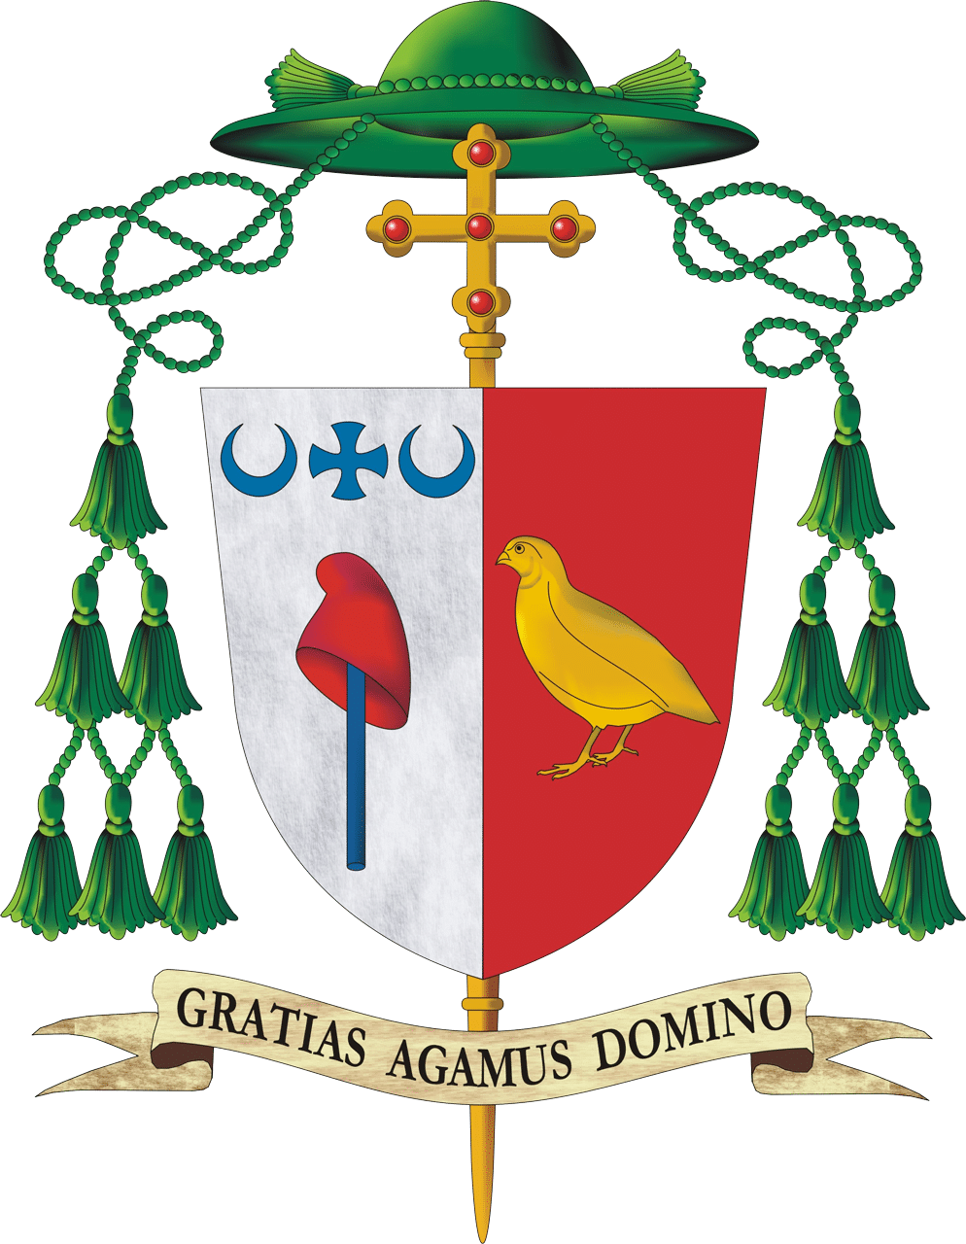
Most Rev. W. Shawn McKnight
Bishop of Jefferson City

